Overview  Country or Region: United States  Industry: Professional Services  Customer Profile  Elite Model Management, owned by billionaire Eddie Trump, is the world’s premier modeling agency and represents approximately 800 models worldwide to fashion designers, ad agencies, magazines, and studios.  Business Situation  Elite’s booking agents had difficulty using an industry-standard software package and often created process shortcuts. In addition, Elite managers had little visibility into financial performance.  Solution  With Infusion Development, Elite created an integrated booking, media management, and billing solution based on Windows Vista™, the 2007 Microsoft® Office system, and Microsoft Exchange Server 2007.  Benefits  - Easy-to-use solution  - Support for workflow and business processes  - Enhanced reporting capabilities |  |  | “This solution makes Elite far more productive and efficient. It’s a great time-saver.”  Neal Hamil, Elite Model Management
 |  |  | Legendary in the fashion world for debuting supermodels, Elite Model Management represents 800 models worldwide to designers, beauty product firms, magazines, and movie studios. While Elite’s models get the limelight, the company’s bottom line depends on scouts, booking agents, and executive management working behind the scenes. To empower these critical employees, Elite worked with Microsoft® Gold Certified Partners Infusion Development and The Henson Group to create an integrated booking, billing, and media management system based on Windows Vista™, the 2007 Microsoft Office system, and Microsoft Exchange Server 2007. The result is an Office Business Application that consolidates applications and allows people to quickly find and act on information, coordinate day-to-day activities, and keep track of important billing processes.
   |  |  | 

Situation
Fast Facts
Number of developers | Two
Estimated months to complete | Three
Developer tools | Microsoft Visual Studio 2005; Microsoft Visual Studio 2005 Tools for the Microsoft Office System
Programming languages | C#
Programming model and technology | Windows Presentation Foundation

"Model and client financial information, which before was available quarterly, is now accessible daily."
Neal Hamil, Elite Model Management

Elite Model Management is famous for its premium level of professional management that supports long-term, balanced modeling careers, and worldwide scouting activities that uncover top modeling talent. Since its inception in 1971, Elite Model Management has launched the careers of many of the modeling industry’s most well-known icons: Stephanie Seymour, Cindy Crawford, Demi Moore, Naomi Campbell, Cameron Diaz, and Linda Evangelista.

Poor Usability Hindered Communication and Collaboration
The heartbeat of Elite’s business is its booking activities. Bookers, as they are informally known in the industry, are the people who match client requests with available models. If Elite’s bookers perform well, the company wins prestigious—and lucrative—contracts, but if they fail to respond to emerging opportunities fast enough and with the right information, Elite risks losing jobs to competing agencies.

When Elite’s bookers receive a cover shoot request from a major fashion magazine, for instance, they need to quickly find the model or models with the right profile and ascertain their availability. The booker then puts together a portfolio package that addresses the specifics of the client request, negotiates terms, and notifies parties involved of the details.

To facilitate these processes, Elite relied on standard industry booking software that theoretically provided necessary functionality. Unfortunately, bookers saw the system as a hindrance and seldom used the solution as intended. In addition, schedules, image repositories, and model profiles were all stored in separate applications, which frustrated bookers and encouraged them to create further process shortcuts.

Lack of Integration Blocked Business Insight
Elite’s separate IT systems not only interfered with the way people wanted to work, they also did not support essential business activities, such as tracking contract expirations. For example, according to their contracts, advertising clients have limited use of an Elite model image. Because the system that stored contracts did not integrate with the financial system, it was difficult to know when a client’s contract had expired.

Executive management also lacked visibility into business information, especially models’ financial performance. In order to keep track of details such as a model’s daily billing rate, cost of travel, and sales and development investment, Elite put together a “management toolbook” every quarter. This task required a week’s effort from a knowledgeable staffer who manually gathered information from different systems.

To solve its problems, Elite needed a solution that not only reported key data to management but would be embraced by booking agents and others responsible for entering that data. An ideal solution would integrate Elite’s disparate systems, enable booking agents to offer superior service, and provide excellent reporting capabilities.

Solution
Elite Model Management turned to Microsoft® Gold Certified Partner Infusion Development to build an Office Business Application that integrates scheduling, media management, and billing functions. Infusion Development suggested building on Elite’s existing IT infrastructure with a customized solution that takes advantage of Windows Vista™, the 2007 Microsoft Office system, Microsoft Exchange Server 2007, and Windows Mobile® software. Infusion Development then reached out to The Henson Group, also a Microsoft Gold Certified Partner, to architect the infrastructure and install, configure, and deploy Microsoft software and server components. The booking solution went into production in January 2007.
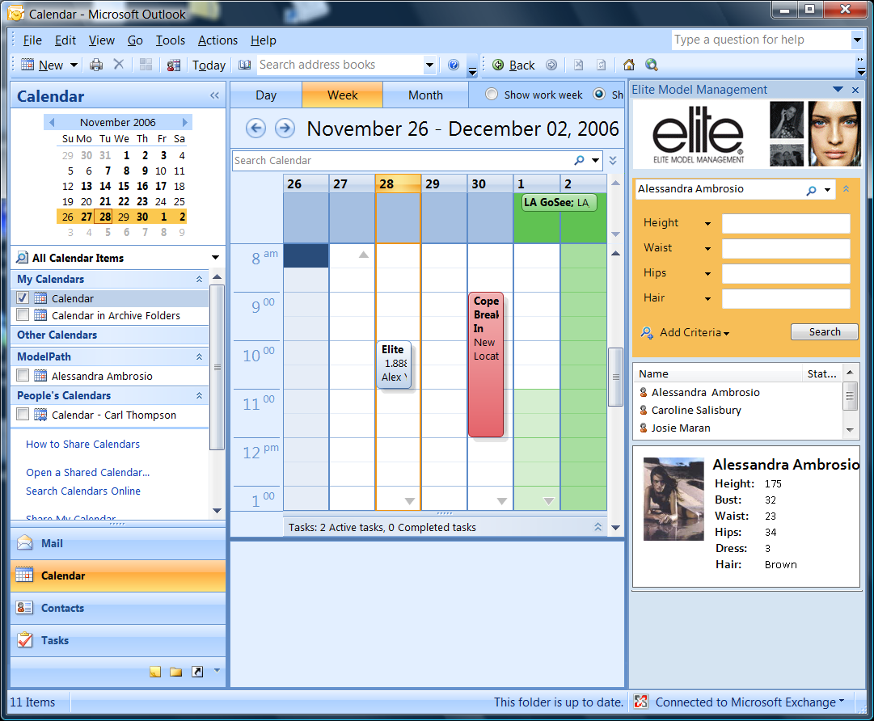
Figure 1. The Elite Model Management system is integrated into the familiar Microsoft Office Outlook interface.
Focusing on the Way People Work
When planning the solution, Elite and Infusion Development focused on solving the day-to-day obstacles bookers, executive managers, and models faced. Because Elite’s booking process starts and ends with communication, the project team extended the familiar Microsoft Office Outlook® client to include important model information and booking options, as shown in Figure 1.

“The new solution is all-encompassing in terms of workflow, and that’s a considerable accomplishment given the intricacies of booking agents’ jobs. Now, bookers can simply right-click a client e-mail and have all the relevant, actionable information appear in a side panel,” says Greg Brill, CEO for Infusion Development.

When they need to choose model portfolios to send to prospective clients, Elite bookers can view model images on a display within the Office Outlook client interface. Infusion developers used Windows® Presentation Foundation, part of the Microsoft .NET Framework 3.0, to create this visually compelling and interactive feature.

Figure 2. Windows Presentation Foundation allows booking agents to browse model portfolios in a visually compelling interface.

Making Technology Attractive
Apart from the Office Outlook integration, the new solution also includes a Windows Presentation Foundation-based application that allows bookers to easily identify—visually—suitable models who are available. The application is accessible through a Gadgets for Windows Sidebar mini-application. When bookers drag the gadget to their desktop, it maximizes into an expanded carousel-style stream of model images, as shown in Figure 2. Clicking on one of the images pulls up the real-time availability and location of the model based on model accounts stored in Exchange Server 2007. With the image carousel, booking agents can quickly browse through model portfolios to find the right model and portfolio collateral.

Empowering Decision Makers
The project team also worked together to create a reporting system that executive management could easily access and customize. The solution exposes Microsoft SQL Server™ 2005 Reporting Services through Microsoft Office SharePoint Server® 2007 so that Elite managers can customize their own reports and reporting portal as needed.

Connecting Around the Globe
Elite’s models are quintessential globetrotters, flying between cities for different jobs, where they bill tens of thousands of dollars each day. In order to keep track of its models and provide them with the latest mobile technology, Elite equipped its models with Microsoft Office Outlook Mobile. Now, up-to-date model schedules are stored in Exchange Server 2007, where the information is instantly available to bookers.

Using the Right Tools
Infusion Development used Microsoft Visual Studio® 2005 Tools for the Microsoft Office System to customize Elite’s Office Outlook messaging and collaboration client. In addition, the project team utilized new workflow capabilities in Office SharePoint Server 2007 to support important workflows, such as tracking model contracts, prospective model applications, and client contracts.

“With Microsoft technology, if you put the products together in the right way, you save yourself massive development effort. There is development, but it’s smart development; it’s creating glue as opposed to creating core functionality, and fitting together the intelligent parts of the Microsoft technology stack,” says Brill.
“With Microsoft technology, if you put the products together in the right way, you save yourself massive development effort.”
Greg Brill, CEO, Infusion Development

Benefits
Together, Windows Vista, the 2007 Office release, Exchange Server 2007, and Windows Mobile software provide Elite Model Management with a powerful Office Business Application that integrates scheduling, media management, and financial reporting. The Office Business Application is especially designed to support Elite bookers’ workflows; corollary benefits include a real-time view of business activity and support for critical business processes, such as tracking contract expirations.

"This solution makes Elite far more productive and efficient. It’s a great time-saver,” says Neal Hamil of Elite Model Management.

Easy-to-Use Solution
The new Elite Model Management system empowers everyone in the organization to obtain the information they need to better manage their business. “We have had excellent user feedback on this Office Business Application. Because we took advantage of existing Office Outlook features and design, the extended functions are immediately familiar and intuitive, and not a lot of training or support is needed,” says Kevin Lasitz, Vice President, Sales & Business Development at Infusion Development.

Windows Presentation Foundation also provides visual user-interface elements that are easier to work with than text alone. “The old booking system was text-based, but bookers are thinking in terms of images and trying to find the right look. Now, they have compelling visual tools that let them work the way they want,” says Lasitz.
“For Elite, the People-Ready vision means enabling its people to collaborate globally, contact clients and models instantly, and streamline and reinvent processes intuitively.”
Greg Henson, CEO, The Henson Group

Microsoft’s People-Ready concept, which focuses on empowering people with the right tools and technologies, inspired Elite to think expansively about its new system. “For Elite, the People-Ready vision means enabling its people to collaborate globally, contact clients and models instantly, and streamline and reinvent processes intuitively,” says Greg Henson, CEO of The Henson Group.

Support for Workflow and Business Processes
Office SharePoint Server 2007 features robust workflow capabilities that help Elite track important processes. For instance, now Elite knows when a client’s contract to use an image is about to expire and can ask them to renew.

Office SharePoint Server 2007 supports Elite’s famous model-scouting activities by providing a single repository where agents and management can track prospective model applications.

Exchange Server 2007 also streamlines business processes by ensuring scheduling information is always accurate, avoiding costly errors. In addition, since the solution is integrated with Office Outlook, booking agents don’t have to switch between applications to determine real-time availability and location.

Enhanced Reporting Capabilities
Because the different Microsoft components integrate easily, Elite can share data among systems. Now, instead of having to manually pull information together for quarterly reporting, Elite managers can create customized reports themselves using SQL Server 2005 Reporting Services exposed through Office SharePoint Server 2007.

"Model and client financial information, which before was available quarterly, is now accessible daily,” says Hamil.
Windows Vista
For More Information
For more information about Microsoft products and services, call the Microsoft Sales Information Center at (800) 426-9400. In Canada, call the Microsoft Canada Information Centre at (877) 568-2495. Customers who are deaf or hard-of-hearing can reach Microsoft text telephone (TTY/TDD) services at (800) 892-5234 in the United States or (905) 568-9641 in Canada. Outside the 50 United States and Canada, please contact your local Microsoft subsidiary. To access information using the World Wide Web, go to:
www.microsoft.com

For more information about Elite Model Management, call (212) 529-9700 or visit the Web site at:
www.elitemodel.com

For more information about Infusion Development products and services, call (212) 732-6100 or visit the Web site at:
www.infusiondev.com

For more information about The Henson Group products and services, call (800) 980-1130 or visit the Web site at:
www.hensongroup.com

© 2007 Microsoft Corporation. This case study is for informational purposes only. MICROSOFT MAKES NO WARRANTIES, EXPRESS OR IMPLIED, IN THIS SUMMARY

Document published February 2007.

Software and Services  - Microsoft Office system  - Microsoft Office Outlook 2007  - Microsoft Office Outlook Mobile  - Microsoft Office SharePoint Server 2007  - Microsoft Servers  - Microsoft Exchange Server 2007  - Microsoft SQL Server 2005  - Microsoft Visual Studio  - Microsoft Visual Studio 2005  - Microsoft Visual Studio 2005 Tools for the Microsoft Office System  - Windows Mobile | - Windows Vista  - Technologies  - Microsoft .NET Framework 3.0  - Windows Presentation Foundation  - Microsoft SQL Server 2005 Reporting Services  - Gadgets for Windows Sidebar  Partners  - Infusion Development (for development)  - The Henson Group (for infrastructure)

Windows Vista can help your organization use information technology to gain a competitive advantage in today’s new world of work. Your people will be able to find and use information more effectively. You will be able to support your mobile work force with better access to shared data and collaboration tools. And your IT staff will have better tools and technologies to enhance corporate IT security, data protection, and more efficient deployment and management.

For more information about Windows Vista, go to:
www.microsoft.com/windowsvista

